Exp No: 6-ARDUINO TO 16x2 LCD DISPLAY USING PROTEUS
AIM:
To write an Embedded C program to interface Arduino Uno and 16 x 2 LCD display using Arduino Uno and Proteus
PROGRAM:
#include <LiquidCrystal.h>
// RS, EN, D4, D5, D6, D7
LiquidCrystal lcd(7, 8, 9, 10, 11, 12);
void setup()
{
lcd.begin(16, 2); // Initialize 16x2 LCD
lcd.print("Hello World!"); // Display message
}
void loop()
{
lcd.scrollDisplayLeft(); // Scroll text to the left
delay(700); // Wait for 700 ms
}

OUTPUT:
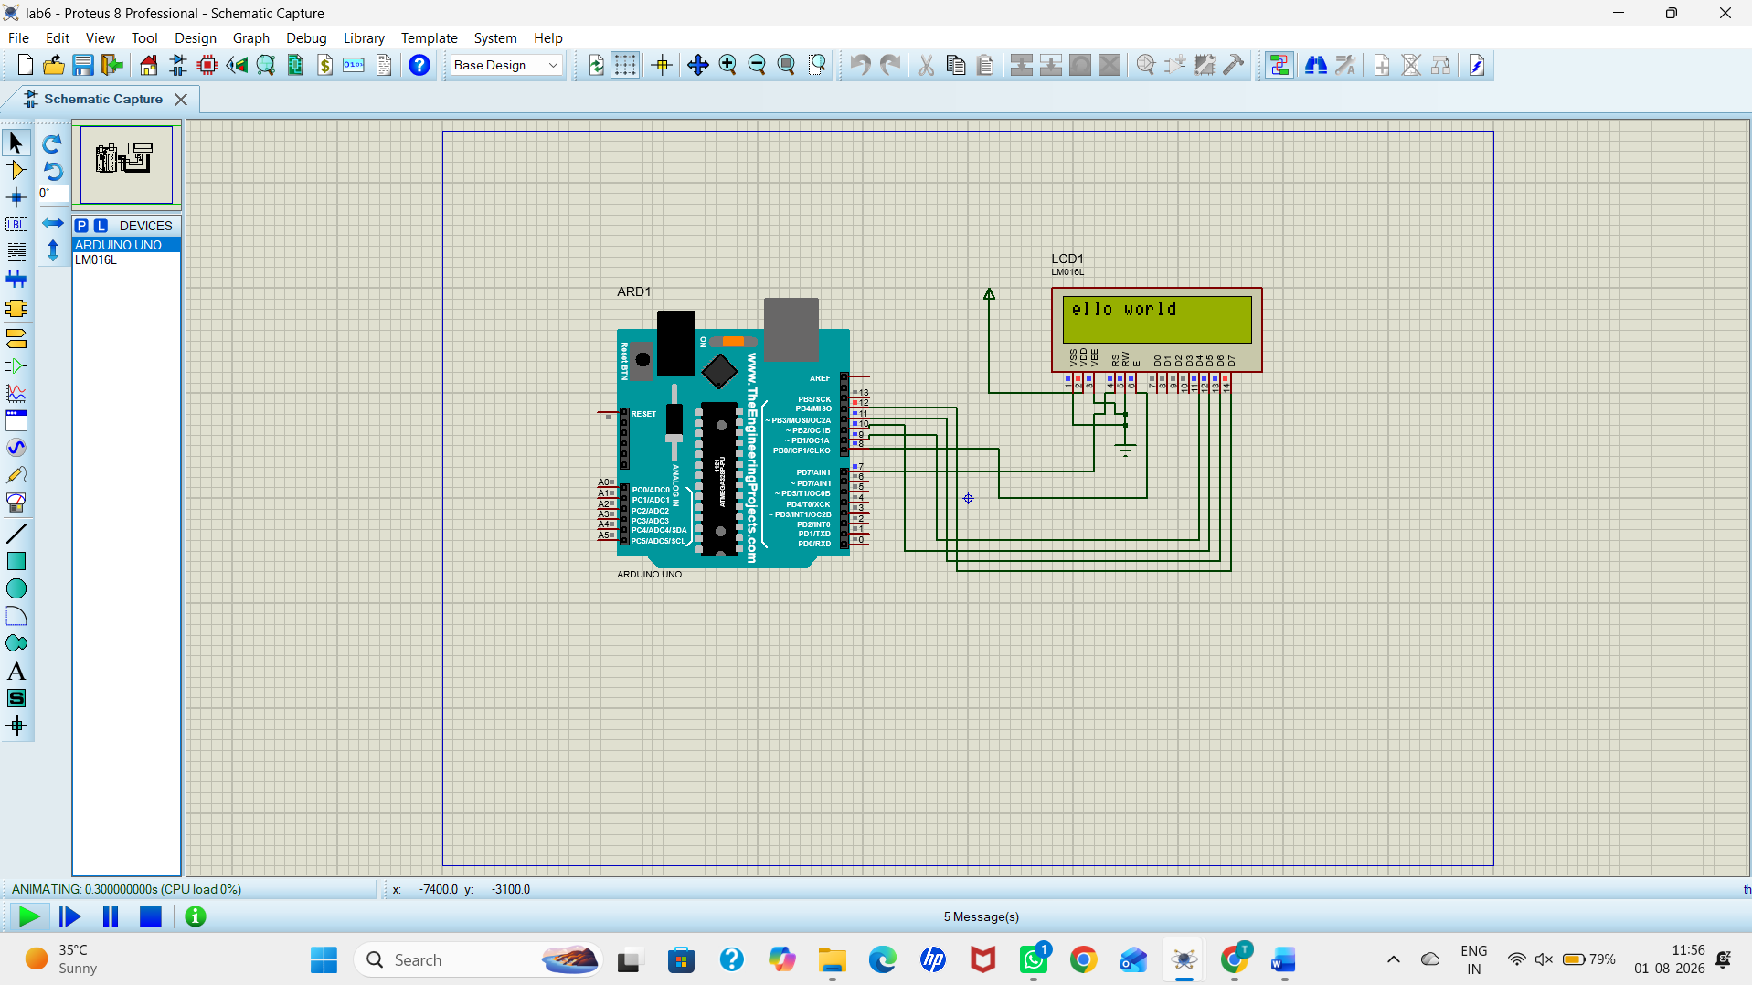
RESULT:
Thus the program has been successfully verified and executed.

